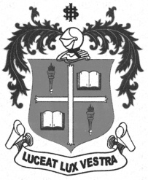
LOYOLA COLLEGE (AUTONOMOUS), CHENNAI – 600 034
M.A. DEGREE EXAMINATION - APPLIED HISTORY
FIRST SEMESTER – APRIL 2012

HT 1808 - CULTURAL HERITAGE OF INDIA

Date : 30-04-2012 Dept. No. Max. : 100 Marks

Time : 9:00 - 12:00

Part-A (4x5=20 Marks)

Answer any FOUR of the following in 100 words each.

- Indology
- Rigveda
- Asiatic Society of Bengal
- Brahma Samaj
- Foreign Trade under Delhi Sutanate
- Hunter Commission on Education
Part-B (2x10=20 Marks)

Answer any TWO of the following in 200 words each.

- Briefly explain the evolution of Feudalism in Medieval India
- Examine the importance of Saba and Samithi of Vedic age in Ancient India.
- State the important provisions of Jagirdari System in Medieval India.
- Write a note on the Bhakthi Movement.
Part-C (3x20=60Marks)

Answer any THREE of the following in 1200 words each.

- Write an essay on the Marxist approach in History.
- Assess the evolution of religious movement in Ancient India
- Discuss the development of Art and Architecture under Mughal India.
- Critically analyse the contributions of British to the Indian Education
- Examine the development of Arts and Music in 19th Century India.

************

